LIBRARY MANAGEMENT SYSTEM
A MINIPROJECT REPORT

Submitted by

M.SHARMILA-1812057
in partial fulfillment for the award of the degree
of
BACHELOR OF ENGINEERING
In
COMPUTER SCIENCE AND ENGINEERING
NATIONAL ENGINEERING COLLEGE
(An Autonomous Institution, Affiliated to Anna University Chennai)
K.R.NAGAR, KOVILPATTI: 628 503

NATIONAL ENGINEERING COLLEGE
(An Autonomous Institution, Affiliated to Anna University Chennai)
K.R.NAGAR, KOVILPATTI: 628 503

BONAFIDE CERTIFICATE

Certified that this Miniproject report “LIBRARY MANAGEMENT SYSTEM” is the bonafide work of “M.SHARMILA(1812057)” who carried out the project work under my supervision.

SIGNATURE
Mr.K.RAJKUMAR M.E.,
ASSITANT PROFESSOR
Dept. of Computer Science and Engineering
NATIONAL ENGINEERING COLLEGE
K.R.NAGAR, KOVILPATTI- 628 503

INTERNAL EXAMINER CO-EXAMINER

TABLE OF CONTENT

CHAPTER NUMBER | TOPIC | PAGE NUMBER
 | ABSTRACT | 2
1 | 1.1 INTRODUCTION TO JAVA | 5
 | 1.2 INTRODUCTION TO JFRAME | 6
2 | 2.1 INTRODUCTION | 7
 | 2.2 SOFTWARE REQUIREMENT | 7
 | 2.3 THE EXISTING SYSTEM | 7
 | 2.4 OBJECTIVES OF PROPOSED SYSTEM | 8
3 | 3.1 APPENDIX 1 | 10
 | 3.2 APPENDIX 2 | 12
 | 3.3 CONCLUSION | 16

ABSTRACT
The library management system is an application for assisting a librarian in managing a book library in a university. The system would provide basic set of features toadd/update members, add/update books, and manage check in specifications for the systems based on the client’s statement of need.
Library management system is a typical management Information system (MIS),

its Development include the establishment and maintenance of back-end database

and front-end application development aspects. For the former require the

establishment of data consistency and integrity of the strong data security and good

libraries. As for the latter requires the application fully functional, easy to use and

so on.

1.1INTRODUCTION TO JAVA:
Java is an entire programming language resembling C or C++. It takes a

sophisticated programmer to create Java code. And it requires a sophisticated

programmer to maintain it. With Java, you can create complete applications. Or

you can attach a small group of instructions, a Java "applet" that improves your

basic HTML. A Java Applet can also cause text to change color when you roll over

it. A game, a calendar, a scrolling text banner can all be created with Java Applets.

There are sometimes compatibility problems between Java and various browsers,

operating systems or computers, and if not written correctly, it can be slow to load.

Java is a powerful programming language with excellent security, but you need to

be aware of the tradeoffs.

Java is a simple, distributed object oriented programming language which provides

the security, High performance, robustness.

Java is a portable and Architectural neutral language which can be Interpreted.

Java is multithreaded and Dynamic language.

java is a Programming language originally developed by James Gosling at Sun

Microsystems and released in 1995 as a core component of Sun Microsystems'

Java Platform. The language derives much of its Syntax from c and C++ but has a

simpler object Model and fewer low-level facilities. Java applications are typically

compiled to bytecode(class file) that can run on any Java Virtual machine (JVM)

regardless of computer architecture.

1.2 INTRODUCTION TO JFRAME:
JFrame is a top-level container that provides a window on the screen. A frame is actually a base window on which other components rely, namely the menu bar, panels, labels, text fields, buttons, etc. Almost every other Swing application starts with the JFrame window. Unlike a frame, JFrame has the option to hide or close the window with the help of the method setDefaultCloseOperation(int).
JFrame class has many constructors that are used to create a new JFrame. You can
create a JFrame using these methods:
JFrame(): This helps in creating a frame which is invisible.
JFrame(String Title): Helps in creating a frame with a title.
JFrame(GraphicsConfiguration gc): Creates a frame with blank title and the graphics configuration of screen.
2.1 INTRODUCTION:
This chapter gives a brief description about the methodologies used for designing this system.
2.2 SOFTWARE REQUIREMENTS:
Language : JAVA
Operating System : Windows 10
Front end :JFRAME
Back end: MYSQL 5.5
2.3 THE EXISTING SYSTEM
System and their relationships within and outside of the system. Here the key

question is- what all problems exist in the present system? What must be done to

solve the problem? Analysis begins when a user or manager begins a study of the

System Analysis is a detailed study of the various operations performed by a

program using existing system.During analysis, data collected on the various files,

decision points and transactions handled by the present system. The success of the

system depends largely on how clearly the problem is defined, thoroughly

investigated and properly carried out through the choice of solution. A good

analysis model should provide not only the mechanisms of problem understanding

but also the frame work of the solution. Thus it should be studied thoroughly by

collecting data about the system. Then the proposed system should be analyzed

thoroughly in accordance with the needs

2.4 OBJECTIVES OF THE PROPOSED SYSTEM

The objectives of Proposed system is an automated Library Management System.

Through our software user can add books, search books, renewal, update

information, edit information, and return books in quick time. Our proposed

system has the following advantages.

. User friendly interface
. Fast access to database
. Less error
. More Storage Capacity
. Search facility
. Look and Feel Environment
. Quick transaction

All the manual difficulties in managing the Library have been rectified by implementing computerization.

3.1 APPENDIX1:
1.)LIBRARYMANAGEMENTSYSTEM.JAVA:

/*
* To change this license header, choose License Headers in Project Properties.
* To change this template file, choose Tools | Templates
* and open the template in the editor.
*/
package library.management.system;

/**
*
* @author Yaleni
*/
public class LibraryManagementSystem {

/**
* @param args the command line arguments
*/
public static void main(String[] args) {
// TODO code application logic here
}

}

2.)LOGIN.JAVA:

import javax.swing.JFrame;
import javax.swing.JOptionPane;

/*
* To change this license header, choose License Headers in Project Properties.
* To change this template file, choose Tools | Templates
* and open the template in the editor.
*/

/**
*
* @author Yaleni
*/
public class login extends javax.swing.JFrame {

/**
* Creates new form login
*/
public login() {
initComponents();
setExtendedState(JFrame.MAXIMIZED_BOTH);
}

/**
* This method is called from within the constructor to initialize the form.
* WARNING: Do NOT modify this code. The content of this method is always
* regenerated by the Form Editor.
*/
@SuppressWarnings("unchecked")
// <editor-fold defaultstate="collapsed" desc="Generated Code">
private void initComponents() {

jLabel3 = new javax.swing.JLabel();
jLabel1 = new javax.swing.JLabel();
jLabel2 = new javax.swing.JLabel();
jTextField1 = new javax.swing.JTextField();
jPasswordField1 = new javax.swing.JPasswordField();
jButton1 = new javax.swing.JButton();
jButton2 = new javax.swing.JButton();
jLabel4 = new javax.swing.JLabel();

jLabel3.setText("jLabel3");

setDefaultCloseOperation(javax.swing.WindowConstants.EXIT_ON_CLOSE);
getContentPane().setLayout(new org.netbeans.lib.awtextra.AbsoluteLayout());

jLabel1.setFont(new java.awt.Font("Tahoma", 1, 24)); // NOI18N
jLabel1.setForeground(new java.awt.Color(255, 255, 255));
jLabel1.setText("Username");
getContentPane().add(jLabel1, new org.netbeans.lib.awtextra.AbsoluteConstraints(750, 460, -1, -1));

jLabel2.setFont(new java.awt.Font("Tahoma", 1, 24)); // NOI18N
jLabel2.setForeground(new java.awt.Color(255, 255, 255));
jLabel2.setText("Password");
getContentPane().add(jLabel2, new org.netbeans.lib.awtextra.AbsoluteConstraints(750, 530, 130, 20));

jTextField1.setBackground(new java.awt.Color(255, 255, 204));
jTextField1.setFont(new java.awt.Font("Tahoma", 1, 14)); // NOI18N
getContentPane().add(jTextField1, new org.netbeans.lib.awtextra.AbsoluteConstraints(910, 470, 310, -1));

jPasswordField1.setBackground(new java.awt.Color(255, 255, 204));
jPasswordField1.setFont(new java.awt.Font("Tahoma", 1, 14)); // NOI18N
jPasswordField1.addActionListener(new java.awt.event.ActionListener() {
public void actionPerformed(java.awt.event.ActionEvent evt) {
jPasswordField1ActionPerformed(evt);
}
});
getContentPane().add(jPasswordField1, new org.netbeans.lib.awtextra.AbsoluteConstraints(910, 530, 310, -1));

jButton1.setBackground(new java.awt.Color(255, 255, 204));
jButton1.setFont(new java.awt.Font("Tahoma", 1, 14)); // NOI18N
jButton1.setIcon(new javax.swing.ImageIcon(getClass().getResource("/login.png"))); // NOI18N
jButton1.setText("Login");
jButton1.addActionListener(new java.awt.event.ActionListener() {
public void actionPerformed(java.awt.event.ActionEvent evt) {
jButton1ActionPerformed(evt);
}
});
getContentPane().add(jButton1, new org.netbeans.lib.awtextra.AbsoluteConstraints(960, 600, -1, -1));

jButton2.setBackground(new java.awt.Color(255, 255, 204));
jButton2.setFont(new java.awt.Font("Tahoma", 1, 14)); // NOI18N
jButton2.setIcon(new javax.swing.ImageIcon(getClass().getResource("/red-x-mark-transparent-background-3.png"))); // NOI18N
jButton2.setText("Close");
jButton2.addActionListener(new java.awt.event.ActionListener() {
public void actionPerformed(java.awt.event.ActionEvent evt) {
jButton2ActionPerformed(evt);
}
});
getContentPane().add(jButton2, new org.netbeans.lib.awtextra.AbsoluteConstraints(1080, 600, -1, -1));

jLabel4.setIcon(new javax.swing.ImageIcon(getClass().getResource("/223-Book Library.png"))); // NOI18N
jLabel4.setText("jLabel4");
getContentPane().add(jLabel4, new org.netbeans.lib.awtextra.AbsoluteConstraints(-300, -100, 2360, 1280));

pack();
}// </editor-fold>

private void jPasswordField1ActionPerformed(java.awt.event.ActionEvent evt) {
// TODO add your handling code here:
}

private void jButton1ActionPerformed(java.awt.event.ActionEvent evt) {
// TODO add your handling code here:
if (jTextField1.getText().equals("admin") && jPasswordField1.getText().equals("admin"))
{
setVisible(false);
new home().setVisible(true);
}
else
JOptionPane.showMessageDialog(null,"Incorrect Username or Password");
}

private void jButton2ActionPerformed(java.awt.event.ActionEvent evt) {
// TODO add your handling code here:
System.exit(0);
}

/**
* @param args the command line arguments
*/
public static void main(String args[]) {
/* Set the Nimbus look and feel */
//<editor-fold defaultstate="collapsed" desc=" Look and feel setting code (optional) ">
/* If Nimbus (introduced in Java SE 6) is not available, stay with the default look and feel.
* For details see http://download.oracle.com/javase/tutorial/uiswing/lookandfeel/plaf.html
*/
try {
for (javax.swing.UIManager.LookAndFeelInfo info : javax.swing.UIManager.getInstalledLookAndFeels()) {
if ("Nimbus".equals(info.getName())) {
javax.swing.UIManager.setLookAndFeel(info.getClassName());
break;
}
}
} catch (ClassNotFoundException ex) {
java.util.logging.Logger.getLogger(login.class.getName()).log(java.util.logging.Level.SEVERE, null, ex);
} catch (InstantiationException ex) {
java.util.logging.Logger.getLogger(login.class.getName()).log(java.util.logging.Level.SEVERE, null, ex);
} catch (IllegalAccessException ex) {
java.util.logging.Logger.getLogger(login.class.getName()).log(java.util.logging.Level.SEVERE, null, ex);
} catch (javax.swing.UnsupportedLookAndFeelException ex) {
java.util.logging.Logger.getLogger(login.class.getName()).log(java.util.logging.Level.SEVERE, null, ex);
}
//</editor-fold>

/* Create and display the form */
java.awt.EventQueue.invokeLater(new Runnable() {
public void run() {
new login().setVisible(true);
}
});
}

// Variables declaration - do not modify
private javax.swing.JButton jButton1;
private javax.swing.JButton jButton2;
private javax.swing.JLabel jLabel1;
private javax.swing.JLabel jLabel2;
private javax.swing.JLabel jLabel3;
private javax.swing.JLabel jLabel4;
private javax.swing.JPasswordField jPasswordField1;
private javax.swing.JTextField jTextField1;
// End of variables declaration
}

3.)HOME.JAVA:

/*
* To change this license header, choose License Headers in Project Properties.
* To change this template file, choose Tools | Templates
* and open the template in the editor.
*/

/**
*
* @author Yaleni
*/
public class home extends javax.swing.JFrame {

/**
* Creates new form home
*/
public home() {
initComponents();
setExtendedState(MAXIMIZED_BOTH);
}

/**
* This method is called from within the constructor to initialize the form.
* WARNING: Do NOT modify this code. The content of this method is always
* regenerated by the Form Editor.
*/
@SuppressWarnings("unchecked")
// <editor-fold defaultstate="collapsed" desc="Generated Code">
private void initComponents() {

jLabel2 = new javax.swing.JLabel();
jButton1 = new javax.swing.JButton();
jButton2 = new javax.swing.JButton();
jButton3 = new javax.swing.JButton();
jButton4 = new javax.swing.JButton();
jButton5 = new javax.swing.JButton();
jButton6 = new javax.swing.JButton();
jLabel1 = new javax.swing.JLabel();

jLabel2.setIcon(new javax.swing.ImageIcon(getClass().getResource("/bg.jpg"))); // NOI18N
jLabel2.setText("jLabel2");

setDefaultCloseOperation(javax.swing.WindowConstants.EXIT_ON_CLOSE);
getContentPane().setLayout(new org.netbeans.lib.awtextra.AbsoluteLayout());

jButton1.setFont(new java.awt.Font("Tahoma", 1, 14)); // NOI18N
jButton1.setIcon(new javax.swing.ImageIcon(getClass().getResource("/member-add-on-300x300.png"))); // NOI18N
jButton1.setText("New Student");
jButton1.addActionListener(new java.awt.event.ActionListener() {
public void actionPerformed(java.awt.event.ActionEvent evt) {
jButton1ActionPerformed(evt);
}
});
getContentPane().add(jButton1, new org.netbeans.lib.awtextra.AbsoluteConstraints(40, 20, -1, -1));

jButton2.setFont(new java.awt.Font("Tahoma", 1, 14)); // NOI18N
jButton2.setIcon(new javax.swing.ImageIcon(getClass().getResource("/New book.png"))); // NOI18N
jButton2.setText("New Book");
jButton2.setPreferredSize(new java.awt.Dimension(159, 59));
jButton2.addActionListener(new java.awt.event.ActionListener() {
public void actionPerformed(java.awt.event.ActionEvent evt) {
jButton2ActionPerformed(evt);
}
});
getContentPane().add(jButton2, new org.netbeans.lib.awtextra.AbsoluteConstraints(400, 20, -1, -1));

jButton3.setFont(new java.awt.Font("Tahoma", 1, 14)); // NOI18N
jButton3.setIcon(new javax.swing.ImageIcon(getClass().getResource("/Statics.png"))); // NOI18N
jButton3.setText("Statistics");
jButton3.setPreferredSize(new java.awt.Dimension(159, 59));
jButton3.addActionListener(new java.awt.event.ActionListener() {
public void actionPerformed(java.awt.event.ActionEvent evt) {
jButton3ActionPerformed(evt);
}
});
getContentPane().add(jButton3, new org.netbeans.lib.awtextra.AbsoluteConstraints(740, 20, 160, -1));

jButton4.setFont(new java.awt.Font("Tahoma", 1, 14)); // NOI18N
jButton4.setIcon(new javax.swing.ImageIcon(getClass().getResource("/issue.png"))); // NOI18N
jButton4.setText("Issue Book");
jButton4.setPreferredSize(new java.awt.Dimension(159, 59));
jButton4.addActionListener(new java.awt.event.ActionListener() {
public void actionPerformed(java.awt.event.ActionEvent evt) {
jButton4ActionPerformed(evt);
}
});
getContentPane().add(jButton4, new org.netbeans.lib.awtextra.AbsoluteConstraints(1090, 20, 170, -1));

jButton5.setFont(new java.awt.Font("Tahoma", 1, 14)); // NOI18N
jButton5.setIcon(new javax.swing.ImageIcon(getClass().getResource("/return-book-1-560407.png"))); // NOI18N
jButton5.setText("Return Book");
jButton5.setPreferredSize(new java.awt.Dimension(159, 59));
jButton5.addActionListener(new java.awt.event.ActionListener() {
public void actionPerformed(java.awt.event.ActionEvent evt) {
jButton5ActionPerformed(evt);
}
});
getContentPane().add(jButton5, new org.netbeans.lib.awtextra.AbsoluteConstraints(1419, 20, 180, -1));

jButton6.setFont(new java.awt.Font("Tahoma", 1, 14)); // NOI18N
jButton6.setIcon(new javax.swing.ImageIcon(getClass().getResource("/exit.png"))); // NOI18N
jButton6.setText("Logout");
jButton6.setPreferredSize(new java.awt.Dimension(159, 59));
jButton6.addActionListener(new java.awt.event.ActionListener() {
public void actionPerformed(java.awt.event.ActionEvent evt) {
jButton6ActionPerformed(evt);
}
});
getContentPane().add(jButton6, new org.netbeans.lib.awtextra.AbsoluteConstraints(1750, 20, -1, -1));

jLabel1.setIcon(new javax.swing.ImageIcon(getClass().getResource("/223-Book Library.png"))); // NOI18N
getContentPane().add(jLabel1, new org.netbeans.lib.awtextra.AbsoluteConstraints(-390, -150, -1, -1));

pack();
}// </editor-fold>

private void jButton2ActionPerformed(java.awt.event.ActionEvent evt) {
// TODO add your handling code here:
new newBook().setVisible(true);
}

private void jButton6ActionPerformed(java.awt.event.ActionEvent evt) {
// TODO add your handling code here:
setVisible(false);
new login().setVisible(true);
}

private void jButton1ActionPerformed(java.awt.event.ActionEvent evt) {
// TODO add your handling code here:
new newStudent().setVisible(true);
}

private void jButton4ActionPerformed(java.awt.event.ActionEvent evt) {
// TODO add your handling code here:
new issueBook().setVisible(true);
}

private void jButton5ActionPerformed(java.awt.event.ActionEvent evt) {
// TODO add your handling code here:
new returnBook().setVisible(true);
}

private void jButton3ActionPerformed(java.awt.event.ActionEvent evt) {
// TODO add your handling code here:
new statistics().setVisible(true);
}

/**
* @param args the command line arguments
*/
public static void main(String args[]) {
/* Set the Nimbus look and feel */
//<editor-fold defaultstate="collapsed" desc=" Look and feel setting code (optional) ">
/* If Nimbus (introduced in Java SE 6) is not available, stay with the default look and feel.
* For details see http://download.oracle.com/javase/tutorial/uiswing/lookandfeel/plaf.html
*/
try {
for (javax.swing.UIManager.LookAndFeelInfo info : javax.swing.UIManager.getInstalledLookAndFeels()) {
if ("Nimbus".equals(info.getName())) {
javax.swing.UIManager.setLookAndFeel(info.getClassName());
break;
}
}
} catch (ClassNotFoundException ex) {
java.util.logging.Logger.getLogger(home.class.getName()).log(java.util.logging.Level.SEVERE, null, ex);
} catch (InstantiationException ex) {
java.util.logging.Logger.getLogger(home.class.getName()).log(java.util.logging.Level.SEVERE, null, ex);
} catch (IllegalAccessException ex) {
java.util.logging.Logger.getLogger(home.class.getName()).log(java.util.logging.Level.SEVERE, null, ex);
} catch (javax.swing.UnsupportedLookAndFeelException ex) {
java.util.logging.Logger.getLogger(home.class.getName()).log(java.util.logging.Level.SEVERE, null, ex);
}
//</editor-fold>

/* Create and display the form */
java.awt.EventQueue.invokeLater(new Runnable() {
public void run() {
new home().setVisible(true);
}
});
}

// Variables declaration - do not modify
private javax.swing.JButton jButton1;
private javax.swing.JButton jButton2;
private javax.swing.JButton jButton3;
private javax.swing.JButton jButton4;
private javax.swing.JButton jButton5;
private javax.swing.JButton jButton6;
private javax.swing.JLabel jLabel1;
private javax.swing.JLabel jLabel2;
// End of variables declaration
}

4.)NEWSTUDENT.JAVA:

import java.sql.*;
import Project.ConnectionProvider;
import javax.swing.JOptionPane;

/*
* To change this license header, choose License Headers in Project Properties.
* To change this template file, choose Tools | Templates
* and open the template in the editor.
*/

/**
*
* @author Yaleni
*/
public class newStudent extends javax.swing.JFrame {

/**
* Creates new form newStudent
*/
public newStudent() {
initComponents();
}

/**
* This method is called from within the constructor to initialize the form.
* WARNING: Do NOT modify this code. The content of this method is always
* regenerated by the Form Editor.
*/
@SuppressWarnings("unchecked")
// <editor-fold defaultstate="collapsed" desc="Generated Code">
private void initComponents() {

jLabel7 = new javax.swing.JLabel();
jLabel1 = new javax.swing.JLabel();
jLabel2 = new javax.swing.JLabel();
jLabel3 = new javax.swing.JLabel();
jLabel4 = new javax.swing.JLabel();
jLabel5 = new javax.swing.JLabel();
jTextField1 = new javax.swing.JTextField();
jTextField2 = new javax.swing.JTextField();
jTextField3 = new javax.swing.JTextField();
jComboBox1 = new javax.swing.JComboBox<>();
jComboBox2 = new javax.swing.JComboBox<>();
jButton1 = new javax.swing.JButton();
jButton2 = new javax.swing.JButton();
jLabel6 = new javax.swing.JLabel();
jComboBox3 = new javax.swing.JComboBox<>();
jLabel8 = new javax.swing.JLabel();

jLabel7.setIcon(new javax.swing.ImageIcon(getClass().getResource("/223-Book Library.png"))); // NOI18N
jLabel7.setText("Y");

setDefaultCloseOperation(javax.swing.WindowConstants.EXIT_ON_CLOSE);
setLocation(new java.awt.Point(500, 200));
setUndecorated(true);
getContentPane().setLayout(new org.netbeans.lib.awtextra.AbsoluteLayout());

jLabel1.setFont(new java.awt.Font("Tahoma", 1, 14)); // NOI18N
jLabel1.setText("Student ID");
getContentPane().add(jLabel1, new org.netbeans.lib.awtextra.AbsoluteConstraints(150, 80, -1, -1));

jLabel2.setFont(new java.awt.Font("Tahoma", 1, 14)); // NOI18N
jLabel2.setText("First Name");
getContentPane().add(jLabel2, new org.netbeans.lib.awtextra.AbsoluteConstraints(150, 140, -1, -1));

jLabel3.setFont(new java.awt.Font("Tahoma", 1, 14)); // NOI18N
jLabel3.setText("Second Name");
getContentPane().add(jLabel3, new org.netbeans.lib.awtextra.AbsoluteConstraints(130, 190, -1, -1));

jLabel4.setFont(new java.awt.Font("Tahoma", 1, 14)); // NOI18N
jLabel4.setText("Course Name");
getContentPane().add(jLabel4, new org.netbeans.lib.awtextra.AbsoluteConstraints(130, 280, -1, -1));

jLabel5.setFont(new java.awt.Font("Tahoma", 1, 14)); // NOI18N
jLabel5.setText("Branch Name");
getContentPane().add(jLabel5, new org.netbeans.lib.awtextra.AbsoluteConstraints(130, 330, -1, -1));

jTextField1.setBackground(new java.awt.Color(255, 255, 204));
jTextField1.setFont(new java.awt.Font("Tahoma", 1, 14)); // NOI18N
getContentPane().add(jTextField1, new org.netbeans.lib.awtextra.AbsoluteConstraints(290, 70, 224, -1));

jTextField2.setBackground(new java.awt.Color(255, 255, 204));
jTextField2.setFont(new java.awt.Font("Tahoma", 1, 14)); // NOI18N
getContentPane().add(jTextField2, new org.netbeans.lib.awtextra.AbsoluteConstraints(290, 130, 224, -1));

jTextField3.setBackground(new java.awt.Color(255, 255, 204));
jTextField3.setFont(new java.awt.Font("Tahoma", 1, 14)); // NOI18N
getContentPane().add(jTextField3, new org.netbeans.lib.awtextra.AbsoluteConstraints(290, 180, 224, -1));

jComboBox1.setBackground(new java.awt.Color(255, 255, 204));
jComboBox1.setFont(new java.awt.Font("Tahoma", 1, 14)); // NOI18N
jComboBox1.setModel(new javax.swing.DefaultComboBoxModel<>(new String[] { "B.E", "B.Tech" }));
getContentPane().add(jComboBox1, new org.netbeans.lib.awtextra.AbsoluteConstraints(290, 280, 224, -1));

jComboBox2.setBackground(new java.awt.Color(255, 255, 204));
jComboBox2.setFont(new java.awt.Font("Tahoma", 1, 14)); // NOI18N
jComboBox2.setModel(new javax.swing.DefaultComboBoxModel<>(new String[] { "CSE", "IT", "MECH", "ECE", "EEE" }));
getContentPane().add(jComboBox2, new org.netbeans.lib.awtextra.AbsoluteConstraints(290, 330, 224, -1));

jButton1.setBackground(new java.awt.Color(255, 255, 204));
jButton1.setFont(new java.awt.Font("Tahoma", 1, 14)); // NOI18N
jButton1.setIcon(new javax.swing.ImageIcon(getClass().getResource("/save-icon--1.png"))); // NOI18N
jButton1.setText("Save");
jButton1.addActionListener(new java.awt.event.ActionListener() {
public void actionPerformed(java.awt.event.ActionEvent evt) {
jButton1ActionPerformed(evt);
}
});
getContentPane().add(jButton1, new org.netbeans.lib.awtextra.AbsoluteConstraints(290, 390, -1, -1));

jButton2.setBackground(new java.awt.Color(255, 255, 204));
jButton2.setFont(new java.awt.Font("Tahoma", 1, 14)); // NOI18N
jButton2.setIcon(new javax.swing.ImageIcon(getClass().getResource("/red-x-mark-transparent-background-3.png"))); // NOI18N
jButton2.setText("Close");
jButton2.addActionListener(new java.awt.event.ActionListener() {
public void actionPerformed(java.awt.event.ActionEvent evt) {
jButton2ActionPerformed(evt);
}
});
getContentPane().add(jButton2, new org.netbeans.lib.awtextra.AbsoluteConstraints(420, 390, -1, -1));

jLabel6.setFont(new java.awt.Font("Tahoma", 1, 14)); // NOI18N
jLabel6.setText(" Year");
getContentPane().add(jLabel6, new org.netbeans.lib.awtextra.AbsoluteConstraints(180, 230, 40, -1));

jComboBox3.setFont(new java.awt.Font("Tahoma", 1, 14)); // NOI18N
jComboBox3.setModel(new javax.swing.DefaultComboBoxModel<>(new String[] { "Ist Year", "IInd Year", "IIIrd Year", "IVth Year" }));
getContentPane().add(jComboBox3, new org.netbeans.lib.awtextra.AbsoluteConstraints(290, 230, 220, -1));

jLabel8.setIcon(new javax.swing.ImageIcon(getClass().getResource("/223-Book Library.png"))); // NOI18N
jLabel8.setText("jLabel8");
getContentPane().add(jLabel8, new org.netbeans.lib.awtextra.AbsoluteConstraints(-1480, -990, -1, -1));

pack();
}// </editor-fold>

private void jButton1ActionPerformed(java.awt.event.ActionEvent evt) {
// TODO add your handling code here:
String studentid=jTextField1.getText();
String name=jTextField2.getText();
String lastname=jTextField3.getText();
String coursename=(String)jComboBox1.getSelectedItem();
String branchname=(String)jComboBox2.getSelectedItem();
String year=(String)jComboBox3.getSelectedItem();

try
{
Connection con=ConnectionProvider.getCon();
Statement st=con.createStatement();
st.executeUpdate("INSERT INTO student VALUES('"+studentid+"','"+name+"','"+lastname+"','"+coursename+"','"+branchname+"','"+year+"')");
JOptionPane.showMessageDialog(null,"Successfully Updated!");
setVisible(false);
new newStudent().setVisible(true);
}
catch(Exception e)
{
JOptionPane.showMessageDialog(null,"StudentID already exist!");
setVisible(false);
new newStudent().setVisible(true);
}

}

private void jButton2ActionPerformed(java.awt.event.ActionEvent evt) {
// TODO add your handling code here:
setVisible(false);
}

/**
* @param args the command line arguments
*/
public static void main(String args[]) {
/* Set the Nimbus look and feel */
//<editor-fold defaultstate="collapsed" desc=" Look and feel setting code (optional) ">
/* If Nimbus (introduced in Java SE 6) is not available, stay with the default look and feel.
* For details see http://download.oracle.com/javase/tutorial/uiswing/lookandfeel/plaf.html
*/
try {
for (javax.swing.UIManager.LookAndFeelInfo info : javax.swing.UIManager.getInstalledLookAndFeels()) {
if ("Nimbus".equals(info.getName())) {
javax.swing.UIManager.setLookAndFeel(info.getClassName());
break;
}
}
} catch (ClassNotFoundException ex) {
java.util.logging.Logger.getLogger(newStudent.class.getName()).log(java.util.logging.Level.SEVERE, null, ex);
} catch (InstantiationException ex) {
java.util.logging.Logger.getLogger(newStudent.class.getName()).log(java.util.logging.Level.SEVERE, null, ex);
} catch (IllegalAccessException ex) {
java.util.logging.Logger.getLogger(newStudent.class.getName()).log(java.util.logging.Level.SEVERE, null, ex);
} catch (javax.swing.UnsupportedLookAndFeelException ex) {
java.util.logging.Logger.getLogger(newStudent.class.getName()).log(java.util.logging.Level.SEVERE, null, ex);
}
//</editor-fold>

/* Create and display the form */
java.awt.EventQueue.invokeLater(new Runnable() {
public void run() {
new newStudent().setVisible(true);
}
});
}

// Variables declaration - do not modify
private javax.swing.JButton jButton1;
private javax.swing.JButton jButton2;
private javax.swing.JComboBox<String> jComboBox1;
private javax.swing.JComboBox<String> jComboBox2;
private javax.swing.JComboBox<String> jComboBox3;
private javax.swing.JLabel jLabel1;
private javax.swing.JLabel jLabel2;
private javax.swing.JLabel jLabel3;
private javax.swing.JLabel jLabel4;
private javax.swing.JLabel jLabel5;
private javax.swing.JLabel jLabel6;
private javax.swing.JLabel jLabel7;
private javax.swing.JLabel jLabel8;
private javax.swing.JTextField jTextField1;
private javax.swing.JTextField jTextField2;
private javax.swing.JTextField jTextField3;
// End of variables declaration
}

5.)NEWBOOK.JAVA:

import java.sql.*;
import Project.ConnectionProvider;
import javax.swing.JOptionPane;

/*
* To change this license header, choose License Headers in Project Properties.
* To change this template file, choose Tools | Templates
* and open the template in the editor.
*/

/**
*
* @author Yaleni
*/
public class newBook extends javax.swing.JFrame {

/**
* Creates new form newBook
*/
public newBook() {
initComponents();
}

/**
* This method is called from within the constructor to initialize the form.
* WARNING: Do NOT modify this code. The content of this method is always
* regenerated by the Form Editor.
*/
@SuppressWarnings("unchecked")
// <editor-fold defaultstate="collapsed" desc="Generated Code">
private void initComponents() {

jLabel1 = new javax.swing.JLabel();
jLabel2 = new javax.swing.JLabel();
jLabel3 = new javax.swing.JLabel();
jLabel4 = new javax.swing.JLabel();
jLabel5 = new javax.swing.JLabel();
jTextField1 = new javax.swing.JTextField();
jTextField2 = new javax.swing.JTextField();
jTextField3 = new javax.swing.JTextField();
jTextField4 = new javax.swing.JTextField();
jTextField5 = new javax.swing.JTextField();
jButton1 = new javax.swing.JButton();
jButton2 = new javax.swing.JButton();
jLabel6 = new javax.swing.JLabel();
jTextField6 = new javax.swing.JTextField();
jLabel7 = new javax.swing.JLabel();

setDefaultCloseOperation(javax.swing.WindowConstants.EXIT_ON_CLOSE);
setLocation(new java.awt.Point(500, 300));
setUndecorated(true);
getContentPane().setLayout(new org.netbeans.lib.awtextra.AbsoluteLayout());

jLabel1.setFont(new java.awt.Font("Tahoma", 1, 14)); // NOI18N
jLabel1.setText("Book ID");
getContentPane().add(jLabel1, new org.netbeans.lib.awtextra.AbsoluteConstraints(140, 70, -1, -1));

jLabel2.setFont(new java.awt.Font("Tahoma", 1, 14)); // NOI18N
jLabel2.setText("Book Name");
getContentPane().add(jLabel2, new org.netbeans.lib.awtextra.AbsoluteConstraints(140, 120, -1, -1));

jLabel3.setFont(new java.awt.Font("Tahoma", 1, 14)); // NOI18N
jLabel3.setText("Publisher");
getContentPane().add(jLabel3, new org.netbeans.lib.awtextra.AbsoluteConstraints(140, 230, -1, -1));

jLabel4.setFont(new java.awt.Font("Tahoma", 1, 14)); // NOI18N
jLabel4.setText("Price");
getContentPane().add(jLabel4, new org.netbeans.lib.awtextra.AbsoluteConstraints(140, 290, -1, -1));

jLabel5.setFont(new java.awt.Font("Tahoma", 1, 14)); // NOI18N
jLabel5.setText("Publisher Year");
getContentPane().add(jLabel5, new org.netbeans.lib.awtextra.AbsoluteConstraints(140, 360, -1, -1));

jTextField1.setBackground(new java.awt.Color(255, 255, 204));
jTextField1.setFont(new java.awt.Font("Tahoma", 1, 14)); // NOI18N
jTextField1.addActionListener(new java.awt.event.ActionListener() {
public void actionPerformed(java.awt.event.ActionEvent evt) {
jTextField1ActionPerformed(evt);
}
});
getContentPane().add(jTextField1, new org.netbeans.lib.awtextra.AbsoluteConstraints(290, 70, 242, -1));

jTextField2.setBackground(new java.awt.Color(255, 255, 204));
jTextField2.setFont(new java.awt.Font("Tahoma", 1, 14)); // NOI18N
getContentPane().add(jTextField2, new org.netbeans.lib.awtextra.AbsoluteConstraints(290, 120, 242, -1));

jTextField3.setBackground(new java.awt.Color(255, 255, 204));
jTextField3.setFont(new java.awt.Font("Tahoma", 1, 14)); // NOI18N
getContentPane().add(jTextField3, new org.netbeans.lib.awtextra.AbsoluteConstraints(290, 230, 242, -1));

jTextField4.setBackground(new java.awt.Color(255, 255, 204));
jTextField4.setFont(new java.awt.Font("Tahoma", 1, 14)); // NOI18N
getContentPane().add(jTextField4, new org.netbeans.lib.awtextra.AbsoluteConstraints(290, 290, 242, -1));

jTextField5.setBackground(new java.awt.Color(255, 255, 204));
jTextField5.setFont(new java.awt.Font("Tahoma", 1, 14)); // NOI18N
getContentPane().add(jTextField5, new org.netbeans.lib.awtextra.AbsoluteConstraints(290, 350, 242, -1));

jButton1.setBackground(new java.awt.Color(255, 255, 204));
jButton1.setFont(new java.awt.Font("Tahoma", 1, 14)); // NOI18N
jButton1.setIcon(new javax.swing.ImageIcon(getClass().getResource("/save-icon--1.png"))); // NOI18N
jButton1.setText("Save");
jButton1.addActionListener(new java.awt.event.ActionListener() {
public void actionPerformed(java.awt.event.ActionEvent evt) {
jButton1ActionPerformed(evt);
}
});
getContentPane().add(jButton1, new org.netbeans.lib.awtextra.AbsoluteConstraints(290, 410, -1, -1));

jButton2.setBackground(new java.awt.Color(255, 255, 204));
jButton2.setFont(new java.awt.Font("Tahoma", 1, 14)); // NOI18N
jButton2.setIcon(new javax.swing.ImageIcon(getClass().getResource("/red-x-mark-transparent-background-3.png"))); // NOI18N
jButton2.setText("Close");
jButton2.addActionListener(new java.awt.event.ActionListener() {
public void actionPerformed(java.awt.event.ActionEvent evt) {
jButton2ActionPerformed(evt);
}
});
getContentPane().add(jButton2, new org.netbeans.lib.awtextra.AbsoluteConstraints(440, 410, -1, -1));

jLabel6.setFont(new java.awt.Font("Tahoma", 1, 14)); // NOI18N
jLabel6.setText("Author Name");
getContentPane().add(jLabel6, new org.netbeans.lib.awtextra.AbsoluteConstraints(140, 170, -1, -1));

jTextField6.setBackground(new java.awt.Color(255, 255, 204));
jTextField6.setFont(new java.awt.Font("Tahoma", 1, 14)); // NOI18N
jTextField6.addActionListener(new java.awt.event.ActionListener() {
public void actionPerformed(java.awt.event.ActionEvent evt) {
jTextField6ActionPerformed(evt);
}
});
getContentPane().add(jTextField6, new org.netbeans.lib.awtextra.AbsoluteConstraints(290, 170, 240, -1));

jLabel7.setIcon(new javax.swing.ImageIcon(getClass().getResource("/223-Book Library.png"))); // NOI18N
jLabel7.setText("jLabel7");
getContentPane().add(jLabel7, new org.netbeans.lib.awtextra.AbsoluteConstraints(-1420, -1030, -1, -1));

pack();
}// </editor-fold>

private void jTextField1ActionPerformed(java.awt.event.ActionEvent evt) {
// TODO add your handling code here:
}

private void jButton2ActionPerformed(java.awt.event.ActionEvent evt) {
// TODO add your handling code here:
setVisible(false);
}

private void jButton1ActionPerformed(java.awt.event.ActionEvent evt) {
// TODO add your handling code here:
String bookid = jTextField1.getText();
String name = jTextField2.getText();
String authorname = jTextField6.getText();
String publisher = jTextField3.getText();
String price = jTextField4.getText();
String publisheryear = jTextField5.getText();
try
{
Connection con=ConnectionProvider.getCon();
Statement st=con.createStatement();
st.executeUpdate("INSERT INTO book VALUES('"+bookid+"','"+name+"','"+publisher+"','"+price+"','"+publisheryear+"','"+authorname+"')");
JOptionPane.showMessageDialog(null,"Hooray!!New Book Details Added In The Database");
setVisible(false);
new newBook().setVisible(true);
}
catch(Exception e)
{
JOptionPane.showMessageDialog(null,"Oops!! This Book Already Exists In The Database");
setVisible(false);
new newBook().setVisible(true);
}
}

private void jTextField6ActionPerformed(java.awt.event.ActionEvent evt) {
// TODO add your handling code here:
}

/**
* @param args the command line arguments
*/
public static void main(String args[]) {
/* Set the Nimbus look and feel */
//<editor-fold defaultstate="collapsed" desc=" Look and feel setting code (optional) ">
/* If Nimbus (introduced in Java SE 6) is not available, stay with the default look and feel.
* For details see http://download.oracle.com/javase/tutorial/uiswing/lookandfeel/plaf.html
*/
try {
for (javax.swing.UIManager.LookAndFeelInfo info : javax.swing.UIManager.getInstalledLookAndFeels()) {
if ("Nimbus".equals(info.getName())) {
javax.swing.UIManager.setLookAndFeel(info.getClassName());
break;
}
}
} catch (ClassNotFoundException ex) {
java.util.logging.Logger.getLogger(newBook.class.getName()).log(java.util.logging.Level.SEVERE, null, ex);
} catch (InstantiationException ex) {
java.util.logging.Logger.getLogger(newBook.class.getName()).log(java.util.logging.Level.SEVERE, null, ex);
} catch (IllegalAccessException ex) {
java.util.logging.Logger.getLogger(newBook.class.getName()).log(java.util.logging.Level.SEVERE, null, ex);
} catch (javax.swing.UnsupportedLookAndFeelException ex) {
java.util.logging.Logger.getLogger(newBook.class.getName()).log(java.util.logging.Level.SEVERE, null, ex);
}
//</editor-fold>

/* Create and display the form */
java.awt.EventQueue.invokeLater(new Runnable() {
public void run() {
new newBook().setVisible(true);
}
});
}

// Variables declaration - do not modify
private javax.swing.JButton jButton1;
private javax.swing.JButton jButton2;
private javax.swing.JLabel jLabel1;
private javax.swing.JLabel jLabel2;
private javax.swing.JLabel jLabel3;
private javax.swing.JLabel jLabel4;
private javax.swing.JLabel jLabel5;
private javax.swing.JLabel jLabel6;
private javax.swing.JLabel jLabel7;
private javax.swing.JTextField jTextField1;
private javax.swing.JTextField jTextField2;
private javax.swing.JTextField jTextField3;
private javax.swing.JTextField jTextField4;
private javax.swing.JTextField jTextField5;
private javax.swing.JTextField jTextField6;
// End of variables declaration
}

6.)ISSUEBOOK.JAVA:

import java.text.SimpleDateFormat;
import java.sql.*;
import Project.ConnectionProvider;
import javax.swing.JOptionPane;

/*
* To change this license header, choose License Headers in Project Properties.
* To change this template file, choose Tools | Templates
* and open the template in the editor.
*/

/**
*
* @author Yaleni
*/
public class issueBook extends javax.swing.JFrame {

/**
* Creates new form issueBook
*/
public issueBook() {
initComponents();
}

/**
* This method is called from within the constructor to initialize the form.
* WARNING: Do NOT modify this code. The content of this method is always
* regenerated by the Form Editor.
*/
@SuppressWarnings("unchecked")
// <editor-fold defaultstate="collapsed" desc="Generated Code">
private void initComponents() {

jLabel1 = new javax.swing.JLabel();
jLabel2 = new javax.swing.JLabel();
jLabel3 = new javax.swing.JLabel();
jLabel4 = new javax.swing.JLabel();
jTextField1 = new javax.swing.JTextField();
jTextField2 = new javax.swing.JTextField();
jDateChooser1 = new com.toedter.calendar.JDateChooser();
jDateChooser2 = new com.toedter.calendar.JDateChooser();
jButton1 = new javax.swing.JButton();
jButton2 = new javax.swing.JButton();
jLabel5 = new javax.swing.JLabel();
jTextField3 = new javax.swing.JTextField();
jLabel7 = new javax.swing.JLabel();
jTextField4 = new javax.swing.JTextField();
jLabel6 = new javax.swing.JLabel();
jTextField5 = new javax.swing.JTextField();
jLabel8 = new javax.swing.JLabel();

setDefaultCloseOperation(javax.swing.WindowConstants.EXIT_ON_CLOSE);
setLocation(new java.awt.Point(500, 300));
setUndecorated(true);
getContentPane().setLayout(new org.netbeans.lib.awtextra.AbsoluteLayout());

jLabel1.setFont(new java.awt.Font("Tahoma", 1, 14)); // NOI18N
jLabel1.setText("Book ID");
getContentPane().add(jLabel1, new org.netbeans.lib.awtextra.AbsoluteConstraints(150, 110, -1, -1));

jLabel2.setFont(new java.awt.Font("Tahoma", 1, 14)); // NOI18N
jLabel2.setText("Student ID");
getContentPane().add(jLabel2, new org.netbeans.lib.awtextra.AbsoluteConstraints(150, 190, -1, -1));

jLabel3.setFont(new java.awt.Font("Tahoma", 1, 14)); // NOI18N
jLabel3.setText("Issue Date");
getContentPane().add(jLabel3, new org.netbeans.lib.awtextra.AbsoluteConstraints(150, 270, -1, -1));

jLabel4.setFont(new java.awt.Font("Tahoma", 1, 14)); // NOI18N
jLabel4.setText("Due Date");
getContentPane().add(jLabel4, new org.netbeans.lib.awtextra.AbsoluteConstraints(150, 320, -1, -1));

jTextField1.setBackground(new java.awt.Color(255, 255, 204));
jTextField1.setFont(new java.awt.Font("Tahoma", 1, 14)); // NOI18N
getContentPane().add(jTextField1, new org.netbeans.lib.awtextra.AbsoluteConstraints(290, 110, 230, -1));

jTextField2.setBackground(new java.awt.Color(255, 255, 204));
jTextField2.setFont(new java.awt.Font("Tahoma", 1, 14)); // NOI18N
getContentPane().add(jTextField2, new org.netbeans.lib.awtextra.AbsoluteConstraints(290, 190, 230, -1));
getContentPane().add(jDateChooser1, new org.netbeans.lib.awtextra.AbsoluteConstraints(290, 270, 230, -1));
getContentPane().add(jDateChooser2, new org.netbeans.lib.awtextra.AbsoluteConstraints(290, 320, 230, -1));

jButton1.setBackground(new java.awt.Color(255, 255, 204));
jButton1.setFont(new java.awt.Font("Tahoma", 1, 14)); // NOI18N
jButton1.setIcon(new javax.swing.ImageIcon(getClass().getResource("/issue book.png"))); // NOI18N
jButton1.setText("Issue");
jButton1.addActionListener(new java.awt.event.ActionListener() {
public void actionPerformed(java.awt.event.ActionEvent evt) {
jButton1ActionPerformed(evt);
}
});
getContentPane().add(jButton1, new org.netbeans.lib.awtextra.AbsoluteConstraints(290, 380, -1, -1));

jButton2.setBackground(new java.awt.Color(255, 255, 204));
jButton2.setFont(new java.awt.Font("Tahoma", 1, 14)); // NOI18N
jButton2.setIcon(new javax.swing.ImageIcon(getClass().getResource("/red-x-mark-transparent-background-3.png"))); // NOI18N
jButton2.setText("Close");
jButton2.addActionListener(new java.awt.event.ActionListener() {
public void actionPerformed(java.awt.event.ActionEvent evt) {
jButton2ActionPerformed(evt);
}
});
getContentPane().add(jButton2, new org.netbeans.lib.awtextra.AbsoluteConstraints(430, 380, -1, -1));

jLabel5.setFont(new java.awt.Font("Tahoma", 1, 14)); // NOI18N
jLabel5.setText("Year & Dept");
getContentPane().add(jLabel5, new org.netbeans.lib.awtextra.AbsoluteConstraints(150, 230, -1, -1));

jTextField3.setBackground(new java.awt.Color(255, 255, 204));
jTextField3.setFont(new java.awt.Font("Tahoma", 1, 14)); // NOI18N
jTextField3.addActionListener(new java.awt.event.ActionListener() {
public void actionPerformed(java.awt.event.ActionEvent evt) {
jTextField3ActionPerformed(evt);
}
});
getContentPane().add(jTextField3, new org.netbeans.lib.awtextra.AbsoluteConstraints(290, 230, 230, -1));

jLabel7.setFont(new java.awt.Font("Tahoma", 1, 14)); // NOI18N
jLabel7.setText("Student Name");
getContentPane().add(jLabel7, new org.netbeans.lib.awtextra.AbsoluteConstraints(150, 150, -1, -1));

jTextField4.setBackground(new java.awt.Color(255, 255, 204));
jTextField4.setFont(new java.awt.Font("Tahoma", 1, 14)); // NOI18N
jTextField4.addActionListener(new java.awt.event.ActionListener() {
public void actionPerformed(java.awt.event.ActionEvent evt) {
jTextField4ActionPerformed(evt);
}
});
getContentPane().add(jTextField4, new org.netbeans.lib.awtextra.AbsoluteConstraints(290, 150, 230, -1));

jLabel6.setFont(new java.awt.Font("Tahoma", 1, 14)); // NOI18N
jLabel6.setText("Book Name");
getContentPane().add(jLabel6, new org.netbeans.lib.awtextra.AbsoluteConstraints(150, 70, -1, -1));

jTextField5.setBackground(new java.awt.Color(255, 255, 204));
jTextField5.setFont(new java.awt.Font("Tahoma", 1, 14)); // NOI18N
getContentPane().add(jTextField5, new org.netbeans.lib.awtextra.AbsoluteConstraints(290, 70, 230, -1));

jLabel8.setIcon(new javax.swing.ImageIcon(getClass().getResource("/223-Book Library.png"))); // NOI18N
jLabel8.setText("jLabel8");
getContentPane().add(jLabel8, new org.netbeans.lib.awtextra.AbsoluteConstraints(-1400, -1020, -1, -1));

pack();
}// </editor-fold>

private void jTextField3ActionPerformed(java.awt.event.ActionEvent evt) {
// TODO add your handling code here:
}

private void jButton2ActionPerformed(java.awt.event.ActionEvent evt) {
// TODO add your handling code here:
setVisible(false);
}

private void jButton1ActionPerformed(java.awt.event.ActionEvent evt) {
// TODO add your handling code here:
SimpleDateFormat dFormat=new SimpleDateFormat("dd-MM-yyyy");
String bookid = jTextField1.getText();
String bookname = jTextField5.getText();
String studentname = jTextField4.getText();
String studentid = jTextField2.getText();
String yearanddept = jTextField3.getText();
String issuedate=dFormat.format(jDateChooser1.getDate());
String duedate=dFormat.format(jDateChooser2.getDate());
String returnbook="No";
try
{
Connection con=ConnectionProvider.getCon();
Statement st=con.createStatement();
ResultSet rs=st.executeQuery("Select * from book where bookid='"+bookid+"'");
if (rs.next())
{
ResultSet rs1=st.executeQuery("select * from student where studentid='"+studentid+"'");
if(rs1.next())
{
st.executeUpdate("insert into issue values('"+bookid+"','"+studentid+"','"+yearanddept+"','"+issuedate+"','"+duedate+"','"+returnbook+"','"+bookname+"','"+studentname+"')");
JOptionPane.showConfirmDialog(null,"Whoo!!Book Issued Successfully");
setVisible(false);
new issueBook().setVisible(true);
}
else
JOptionPane.showConfirmDialog(null,"Sorry!!Incorrect StudentID");
}
else
JOptionPane.showConfirmDialog(null,"Sorry!!Incorrect BookID");
}
catch(Exception e)
{
JOptionPane.showConfirmDialog(null,"Sorry!!Connection Error");
}

}

private void jTextField4ActionPerformed(java.awt.event.ActionEvent evt) {
// TODO add your handling code here:
}

/**
* @param args the command line arguments
*/
public static void main(String args[]) {
/* Set the Nimbus look and feel */
//<editor-fold defaultstate="collapsed" desc=" Look and feel setting code (optional) ">
/* If Nimbus (introduced in Java SE 6) is not available, stay with the default look and feel.
* For details see http://download.oracle.com/javase/tutorial/uiswing/lookandfeel/plaf.html
*/
try {
for (javax.swing.UIManager.LookAndFeelInfo info : javax.swing.UIManager.getInstalledLookAndFeels()) {
if ("Nimbus".equals(info.getName())) {
javax.swing.UIManager.setLookAndFeel(info.getClassName());
break;
}
}
} catch (ClassNotFoundException ex) {
java.util.logging.Logger.getLogger(issueBook.class.getName()).log(java.util.logging.Level.SEVERE, null, ex);
} catch (InstantiationException ex) {
java.util.logging.Logger.getLogger(issueBook.class.getName()).log(java.util.logging.Level.SEVERE, null, ex);
} catch (IllegalAccessException ex) {
java.util.logging.Logger.getLogger(issueBook.class.getName()).log(java.util.logging.Level.SEVERE, null, ex);
} catch (javax.swing.UnsupportedLookAndFeelException ex) {
java.util.logging.Logger.getLogger(issueBook.class.getName()).log(java.util.logging.Level.SEVERE, null, ex);
}
//</editor-fold>

/* Create and display the form */
java.awt.EventQueue.invokeLater(new Runnable() {
public void run() {
new issueBook().setVisible(true);
}
});
}

// Variables declaration - do not modify
private javax.swing.JButton jButton1;
private javax.swing.JButton jButton2;
private com.toedter.calendar.JDateChooser jDateChooser1;
private com.toedter.calendar.JDateChooser jDateChooser2;
private javax.swing.JLabel jLabel1;
private javax.swing.JLabel jLabel2;
private javax.swing.JLabel jLabel3;
private javax.swing.JLabel jLabel4;
private javax.swing.JLabel jLabel5;
private javax.swing.JLabel jLabel6;
private javax.swing.JLabel jLabel7;
private javax.swing.JLabel jLabel8;
private javax.swing.JTextField jTextField1;
private javax.swing.JTextField jTextField2;
private javax.swing.JTextField jTextField3;
private javax.swing.JTextField jTextField4;
private javax.swing.JTextField jTextField5;
// End of variables declaration
}

7.)RETURNBOOK.JAVA:

import java.sql.*;
import Project.ConnectionProvider;
import javax.swing.JOptionPane;
/*
* To change this license header, choose License Headers in Project Properties.
* To change this template file, choose Tools | Templates
* and open the template in the editor.
*/

/**
*
* @author Yaleni
*/
public class returnBook extends javax.swing.JFrame {

/**
* Creates new form returnBook
*/
public returnBook() {
initComponents();
}

/**
* This method is called from within the constructor to initialize the form.
* WARNING: Do NOT modify this code. The content of this method is always
* regenerated by the Form Editor.
*/
@SuppressWarnings("unchecked")
// <editor-fold defaultstate="collapsed" desc="Generated Code">
private void initComponents() {

jDateChooser1 = new com.toedter.calendar.JDateChooser();
jLabel1 = new javax.swing.JLabel();
jLabel2 = new javax.swing.JLabel();
jLabel3 = new javax.swing.JLabel();
jLabel4 = new javax.swing.JLabel();
jLabel5 = new javax.swing.JLabel();
jLabel6 = new javax.swing.JLabel();
jLabel7 = new javax.swing.JLabel();
jTextField1 = new javax.swing.JTextField();
jTextField2 = new javax.swing.JTextField();
jTextField3 = new javax.swing.JTextField();
jTextField4 = new javax.swing.JTextField();
jTextField5 = new javax.swing.JTextField();
jTextField6 = new javax.swing.JTextField();
jTextField7 = new javax.swing.JTextField();
jButton1 = new javax.swing.JButton();
jButton2 = new javax.swing.JButton();
jButton3 = new javax.swing.JButton();
jLabel8 = new javax.swing.JLabel();

setDefaultCloseOperation(javax.swing.WindowConstants.EXIT_ON_CLOSE);
setLocation(new java.awt.Point(500, 300));
setUndecorated(true);
getContentPane().setLayout(new org.netbeans.lib.awtextra.AbsoluteLayout());

jLabel1.setFont(new java.awt.Font("Tahoma", 1, 14)); // NOI18N
jLabel1.setText("Book ID");
getContentPane().add(jLabel1, new org.netbeans.lib.awtextra.AbsoluteConstraints(209, 16, -1, -1));

jLabel2.setFont(new java.awt.Font("Tahoma", 1, 14)); // NOI18N
jLabel2.setText("Book Name");
getContentPane().add(jLabel2, new org.netbeans.lib.awtextra.AbsoluteConstraints(209, 71, -1, -1));

jLabel3.setFont(new java.awt.Font("Tahoma", 1, 14)); // NOI18N
jLabel3.setText("Student ID");
getContentPane().add(jLabel3, new org.netbeans.lib.awtextra.AbsoluteConstraints(209, 125, -1, -1));

jLabel4.setFont(new java.awt.Font("Tahoma", 1, 14)); // NOI18N
jLabel4.setText("Student Name");
getContentPane().add(jLabel4, new org.netbeans.lib.awtextra.AbsoluteConstraints(209, 177, -1, -1));

jLabel5.setFont(new java.awt.Font("Tahoma", 1, 14)); // NOI18N
jLabel5.setText("Year & Dept");
getContentPane().add(jLabel5, new org.netbeans.lib.awtextra.AbsoluteConstraints(209, 232, -1, -1));

jLabel6.setFont(new java.awt.Font("Tahoma", 1, 14)); // NOI18N
jLabel6.setText("Issue Date");
getContentPane().add(jLabel6, new org.netbeans.lib.awtextra.AbsoluteConstraints(209, 288, -1, -1));

jLabel7.setFont(new java.awt.Font("Tahoma", 1, 14)); // NOI18N
jLabel7.setText("Due Date");
getContentPane().add(jLabel7, new org.netbeans.lib.awtextra.AbsoluteConstraints(209, 352, -1, -1));

jTextField1.setBackground(new java.awt.Color(255, 255, 204));
jTextField1.setFont(new java.awt.Font("Tahoma", 1, 14)); // NOI18N
getContentPane().add(jTextField1, new org.netbeans.lib.awtextra.AbsoluteConstraints(385, 13, 200, -1));

jTextField2.setBackground(new java.awt.Color(255, 255, 204));
jTextField2.setFont(new java.awt.Font("Tahoma", 1, 14)); // NOI18N
getContentPane().add(jTextField2, new org.netbeans.lib.awtextra.AbsoluteConstraints(385, 68, 200, -1));

jTextField3.setBackground(new java.awt.Color(255, 255, 204));
jTextField3.setFont(new java.awt.Font("Tahoma", 1, 14)); // NOI18N
jTextField3.addActionListener(new java.awt.event.ActionListener() {
public void actionPerformed(java.awt.event.ActionEvent evt) {
jTextField3ActionPerformed(evt);
}
});
getContentPane().add(jTextField3, new org.netbeans.lib.awtextra.AbsoluteConstraints(385, 122, 200, -1));

jTextField4.setBackground(new java.awt.Color(255, 255, 204));
jTextField4.setFont(new java.awt.Font("Tahoma", 1, 14)); // NOI18N
getContentPane().add(jTextField4, new org.netbeans.lib.awtextra.AbsoluteConstraints(385, 174, 200, -1));

jTextField5.setBackground(new java.awt.Color(255, 255, 204));
jTextField5.setFont(new java.awt.Font("Tahoma", 1, 14)); // NOI18N
getContentPane().add(jTextField5, new org.netbeans.lib.awtextra.AbsoluteConstraints(385, 229, 200, -1));

jTextField6.setBackground(new java.awt.Color(255, 255, 204));
jTextField6.setFont(new java.awt.Font("Tahoma", 1, 14)); // NOI18N
jTextField6.addActionListener(new java.awt.event.ActionListener() {
public void actionPerformed(java.awt.event.ActionEvent evt) {
jTextField6ActionPerformed(evt);
}
});
getContentPane().add(jTextField6, new org.netbeans.lib.awtextra.AbsoluteConstraints(385, 285, 200, -1));

jTextField7.setBackground(new java.awt.Color(255, 255, 204));
jTextField7.setFont(new java.awt.Font("Tahoma", 1, 14)); // NOI18N
getContentPane().add(jTextField7, new org.netbeans.lib.awtextra.AbsoluteConstraints(385, 349, 200, -1));

jButton1.setBackground(new java.awt.Color(255, 255, 204));
jButton1.setFont(new java.awt.Font("Tahoma", 1, 14)); // NOI18N
jButton1.setIcon(new javax.swing.ImageIcon(getClass().getResource("/return book png.png"))); // NOI18N
jButton1.setText("Return");
jButton1.addActionListener(new java.awt.event.ActionListener() {
public void actionPerformed(java.awt.event.ActionEvent evt) {
jButton1ActionPerformed(evt);
}
});
getContentPane().add(jButton1, new org.netbeans.lib.awtextra.AbsoluteConstraints(355, 399, -1, -1));

jButton2.setBackground(new java.awt.Color(255, 255, 204));
jButton2.setFont(new java.awt.Font("Tahoma", 1, 14)); // NOI18N
jButton2.setIcon(new javax.swing.ImageIcon(getClass().getResource("/red-x-mark-transparent-background-3.png"))); // NOI18N
jButton2.setText("Close");
jButton2.addActionListener(new java.awt.event.ActionListener() {
public void actionPerformed(java.awt.event.ActionEvent evt) {
jButton2ActionPerformed(evt);
}
});
getContentPane().add(jButton2, new org.netbeans.lib.awtextra.AbsoluteConstraints(501, 399, -1, -1));

jButton3.setBackground(new java.awt.Color(255, 255, 204));
jButton3.setFont(new java.awt.Font("Tahoma", 1, 14)); // NOI18N
jButton3.setIcon(new javax.swing.ImageIcon(getClass().getResource("/search.png"))); // NOI18N
jButton3.setText("Search");
jButton3.addActionListener(new java.awt.event.ActionListener() {
public void actionPerformed(java.awt.event.ActionEvent evt) {
jButton3ActionPerformed(evt);
}
});
getContentPane().add(jButton3, new org.netbeans.lib.awtextra.AbsoluteConstraints(209, 399, -1, -1));

jLabel8.setIcon(new javax.swing.ImageIcon(getClass().getResource("/223-Book Library.png"))); // NOI18N
jLabel8.setText("jLabel8");
getContentPane().add(jLabel8, new org.netbeans.lib.awtextra.AbsoluteConstraints(-1440, -1020, -1, -1));

pack();
}// </editor-fold>

private void jTextField3ActionPerformed(java.awt.event.ActionEvent evt) {
// TODO add your handling code here:
}

private void jButton3ActionPerformed(java.awt.event.ActionEvent evt) {
// TODO add your handling code here:
String bookid;
bookid = jTextField1.getText();
String bookname=jTextField2.getText();
String studentid;
studentid = jTextField3.getText();
String studentname=jTextField4.getText();
String yearanddept=jTextField5.getText();
try
{
Connection con = ConnectionProvider.getCon();
Statement st = con.createStatement();
ResultSet rs = st.executeQuery("SELECT * FROM issue WHERE bookid='"+bookid+"' AND studentid='"+studentid+"'");
if (rs.next())
{
jTextField6.setText(rs.getString(4));
jTextField7.setText(rs.getString(5));
jTextField1.setEditable(false);
jTextField3.setEditable(false);
JOptionPane.showMessageDialog(null,"Book Found");

}
else
JOptionPane.showMessageDialog(null,"Book Is Not Issued To This Student");
setVisible(false);
new returnBook().setVisible(true);

}
catch(Exception e)
{
JOptionPane.showMessageDialog(null,"Oops!!Connection Error");
}
}

private void jButton1ActionPerformed(java.awt.event.ActionEvent evt) {
// TODO add your handling code here:
String bookid=jTextField1.getText();
String bookname=jTextField2.getText();
String studentid=jTextField3.getText();
String studentname=jTextField4.getText();
String yearanddept=jTextField5.getText();
try
{
Connection con = ConnectionProvider.getCon();
Statement st = con.createStatement();
st.executeUpdate("update issue set returnstatus='YES' where studentid='"+studentid+"' and bookid='"+bookid+"'");
JOptionPane.showMessageDialog(null,"Thank You.,Book Successfully Returned");
setVisible(false);
new returnBook().setVisible(true);
}
catch(Exception e)
{
JOptionPane.showMessageDialog(null,"Oops!!Connection Error");
}
}

private void jButton2ActionPerformed(java.awt.event.ActionEvent evt) {
// TODO add your handling code here:
setVisible(false);
}

private void jTextField6ActionPerformed(java.awt.event.ActionEvent evt) {

}

/**
* @param args the command line arguments
*/
public static void main(String args[]) {
/* Set the Nimbus look and feel */
//<editor-fold defaultstate="collapsed" desc=" Look and feel setting code (optional) ">
/* If Nimbus (introduced in Java SE 6) is not available, stay with the default look and feel.
* For details see http://download.oracle.com/javase/tutorial/uiswing/lookandfeel/plaf.html
*/
try {
for (javax.swing.UIManager.LookAndFeelInfo info : javax.swing.UIManager.getInstalledLookAndFeels()) {
if ("Nimbus".equals(info.getName())) {
javax.swing.UIManager.setLookAndFeel(info.getClassName());
break;
}
}
} catch (ClassNotFoundException ex) {
java.util.logging.Logger.getLogger(returnBook.class.getName()).log(java.util.logging.Level.SEVERE, null, ex);
} catch (InstantiationException ex) {
java.util.logging.Logger.getLogger(returnBook.class.getName()).log(java.util.logging.Level.SEVERE, null, ex);
} catch (IllegalAccessException ex) {
java.util.logging.Logger.getLogger(returnBook.class.getName()).log(java.util.logging.Level.SEVERE, null, ex);
} catch (javax.swing.UnsupportedLookAndFeelException ex) {
java.util.logging.Logger.getLogger(returnBook.class.getName()).log(java.util.logging.Level.SEVERE, null, ex);
}
//</editor-fold>

/* Create and display the form */
java.awt.EventQueue.invokeLater(new Runnable() {
public void run() {
new returnBook().setVisible(true);
}
});
}

// Variables declaration - do not modify
private javax.swing.JButton jButton1;
private javax.swing.JButton jButton2;
private javax.swing.JButton jButton3;
private com.toedter.calendar.JDateChooser jDateChooser1;
private javax.swing.JLabel jLabel1;
private javax.swing.JLabel jLabel2;
private javax.swing.JLabel jLabel3;
private javax.swing.JLabel jLabel4;
private javax.swing.JLabel jLabel5;
private javax.swing.JLabel jLabel6;
private javax.swing.JLabel jLabel7;
private javax.swing.JLabel jLabel8;
private javax.swing.JTextField jTextField1;
private javax.swing.JTextField jTextField2;
private javax.swing.JTextField jTextField3;
private javax.swing.JTextField jTextField4;
private javax.swing.JTextField jTextField5;
private javax.swing.JTextField jTextField6;
private javax.swing.JTextField jTextField7;
// End of variables declaration
}

8.)STATISTICS.JAVA:

import java.sql.*;
import Project.ConnectionProvider;
import javax.swing.JOptionPane;
import net.proteanit.sql.DbUtils;
/*
* To change this license header, choose License Headers in Project Properties.
* To change this template file, choose Tools | Templates
* and open the template in the editor.
*/

/**
*
* @author Yaleni
*/
public class statistics extends javax.swing.JFrame {

/**
* Creates new form statistics
*/
public statistics() {
initComponents();
}

/**
* This method is called from within the constructor to initialize the form.
* WARNING: Do NOT modify this code. The content of this method is always
* regenerated by the Form Editor.
*/
@SuppressWarnings("unchecked")
// <editor-fold defaultstate="collapsed" desc="Generated Code">
private void initComponents() {

jLabel1 = new javax.swing.JLabel();
jScrollPane1 = new javax.swing.JScrollPane();
jTable1 = new javax.swing.JTable();
jLabel2 = new javax.swing.JLabel();
jScrollPane2 = new javax.swing.JScrollPane();
jTable2 = new javax.swing.JTable();
jButton1 = new javax.swing.JButton();
jLabel3 = new javax.swing.JLabel();

setDefaultCloseOperation(javax.swing.WindowConstants.EXIT_ON_CLOSE);
setLocation(new java.awt.Point(500, 300));
setUndecorated(true);
addComponentListener(new java.awt.event.ComponentAdapter() {
public void componentShown(java.awt.event.ComponentEvent evt) {
formComponentShown(evt);
}
});
getContentPane().setLayout(new org.netbeans.lib.awtextra.AbsoluteLayout());

jLabel1.setFont(new java.awt.Font("Tahoma", 1, 14)); // NOI18N
jLabel1.setText("Issue Details");
getContentPane().add(jLabel1, new org.netbeans.lib.awtextra.AbsoluteConstraints(390, 90, -1, -1));

jTable1.setBackground(new java.awt.Color(255, 255, 204));
jTable1.setModel(new javax.swing.table.DefaultTableModel(
new Object [][] {
{null, null, null, null},
{null, null, null, null},
{null, null, null, null},
{null, null, null, null}
},
new String [] {
"Title 1", "Title 2", "Title 3", "Title 4"
}
));
jScrollPane1.setViewportView(jTable1);

getContentPane().add(jScrollPane1, new org.netbeans.lib.awtextra.AbsoluteConstraints(90, 120, 676, 101));

jLabel2.setFont(new java.awt.Font("Tahoma", 1, 14)); // NOI18N
jLabel2.setText("Return Details");
getContentPane().add(jLabel2, new org.netbeans.lib.awtextra.AbsoluteConstraints(390, 260, -1, -1));

jTable2.setBackground(new java.awt.Color(255, 255, 204));
jTable2.setModel(new javax.swing.table.DefaultTableModel(
new Object [][] {
{null, null, null, null},
{null, null, null, null},
{null, null, null, null},
{null, null, null, null}
},
new String [] {
"Title 1", "Title 2", "Title 3", "Title 4"
}
));
jScrollPane2.setViewportView(jTable2);

getContentPane().add(jScrollPane2, new org.netbeans.lib.awtextra.AbsoluteConstraints(90, 300, 676, 117));

jButton1.setBackground(new java.awt.Color(255, 255, 204));
jButton1.setFont(new java.awt.Font("Tahoma", 1, 14)); // NOI18N
jButton1.setIcon(new javax.swing.ImageIcon(getClass().getResource("/red-x-mark-transparent-background-3.png"))); // NOI18N
jButton1.setText("Close");
jButton1.addActionListener(new java.awt.event.ActionListener() {
public void actionPerformed(java.awt.event.ActionEvent evt) {
jButton1ActionPerformed(evt);
}
});
getContentPane().add(jButton1, new org.netbeans.lib.awtextra.AbsoluteConstraints(600, 460, -1, -1));

jLabel3.setIcon(new javax.swing.ImageIcon(getClass().getResource("/223-Book Library.png"))); // NOI18N
getContentPane().add(jLabel3, new org.netbeans.lib.awtextra.AbsoluteConstraints(-1290, -450, -1, -1));

pack();
}// </editor-fold>

private void formComponentShown(java.awt.event.ComponentEvent evt) {
// TODO add your handling code here:
try
{
Connection con=ConnectionProvider.getCon();
Statement st = con.createStatement();
ResultSet rs=st.executeQuery("select issue.studentid,student.firstname,issue.bookid,book.bookname,issue.issuedate,issue.duedate from student inner join book inner join issue where book.bookid = issue.bookid and student.studentid = issue.studentid and issue.returnstatus='NO'");
jTable1.setModel(DbUtils.resultSetToTableModel(rs));
ResultSet rs1=st.executeQuery("select issue.studentid,student.firstname,issue.bookid,book.bookname,issue.issuedate,issue.duedate from student inner join book inner join issue where book.bookid = issue.bookid and student.studentid = issue.studentid and issue.returnstatus='YES'");
jTable2.setModel(DbUtils.resultSetToTableModel(rs1));
}
catch(Exception e)
{
JOptionPane.showMessageDialog(null,"Connection Error!!");
}

}

private void jButton1ActionPerformed(java.awt.event.ActionEvent evt) {
// TODO add your handling code here:
setVisible(false);
}

/**
* @param args the command line arguments
*/
public static void main(String args[]) {
/* Set the Nimbus look and feel */
//<editor-fold defaultstate="collapsed" desc=" Look and feel setting code (optional) ">
/* If Nimbus (introduced in Java SE 6) is not available, stay with the default look and feel.
* For details see http://download.oracle.com/javase/tutorial/uiswing/lookandfeel/plaf.html
*/
try {
for (javax.swing.UIManager.LookAndFeelInfo info : javax.swing.UIManager.getInstalledLookAndFeels()) {
if ("Nimbus".equals(info.getName())) {
javax.swing.UIManager.setLookAndFeel(info.getClassName());
break;
}
}
} catch (ClassNotFoundException ex) {
java.util.logging.Logger.getLogger(statistics.class.getName()).log(java.util.logging.Level.SEVERE, null, ex);
} catch (InstantiationException ex) {
java.util.logging.Logger.getLogger(statistics.class.getName()).log(java.util.logging.Level.SEVERE, null, ex);
} catch (IllegalAccessException ex) {
java.util.logging.Logger.getLogger(statistics.class.getName()).log(java.util.logging.Level.SEVERE, null, ex);
} catch (javax.swing.UnsupportedLookAndFeelException ex) {
java.util.logging.Logger.getLogger(statistics.class.getName()).log(java.util.logging.Level.SEVERE, null, ex);
}
//</editor-fold>

/* Create and display the form */
java.awt.EventQueue.invokeLater(new Runnable() {
public void run() {
new statistics().setVisible(true);
}
});
}

// Variables declaration - do not modify
private javax.swing.JButton jButton1;
private javax.swing.JLabel jLabel1;
private javax.swing.JLabel jLabel2;
private javax.swing.JLabel jLabel3;
private javax.swing.JScrollPane jScrollPane1;
private javax.swing.JScrollPane jScrollPane2;
private javax.swing.JTable jTable1;
private javax.swing.JTable jTable2;
// End of variables declaration
}

9.)CONNECTIONPROVIDER.JAVA:

/*
* To change this license header, choose License Headers in Project Properties.
* To change this template file, choose Tools | Templates
* and open the template in the editor.
*/
package Project;
import java.sql.*;

/**
*
* @author Yaleni
*/
public class ConnectionProvider {
public static Connection getCon()
{
try
{
Class.forName("com.mysql.jdbc.Driver");
Connection con=DriverManager.getConnection("jdbc:mysql://localhost:3307/lms","root","1234");
return con;
}
catch(Exception e)
{
System.out.println(e);
return null;
}
}

}

3.2 APPENDIX 2
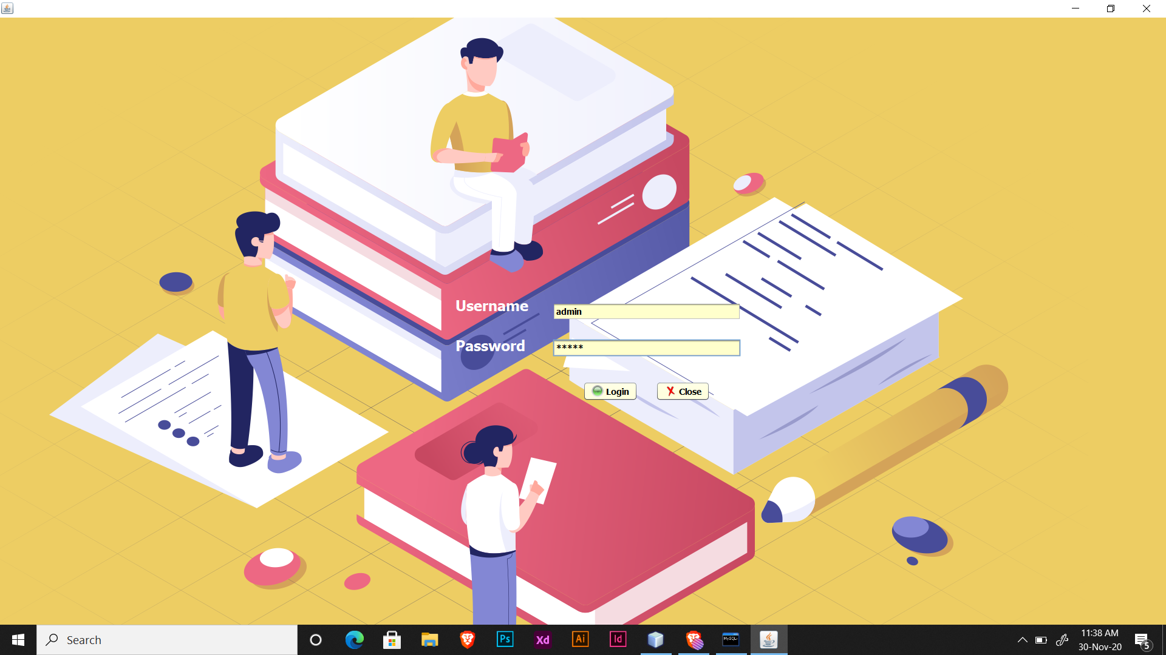
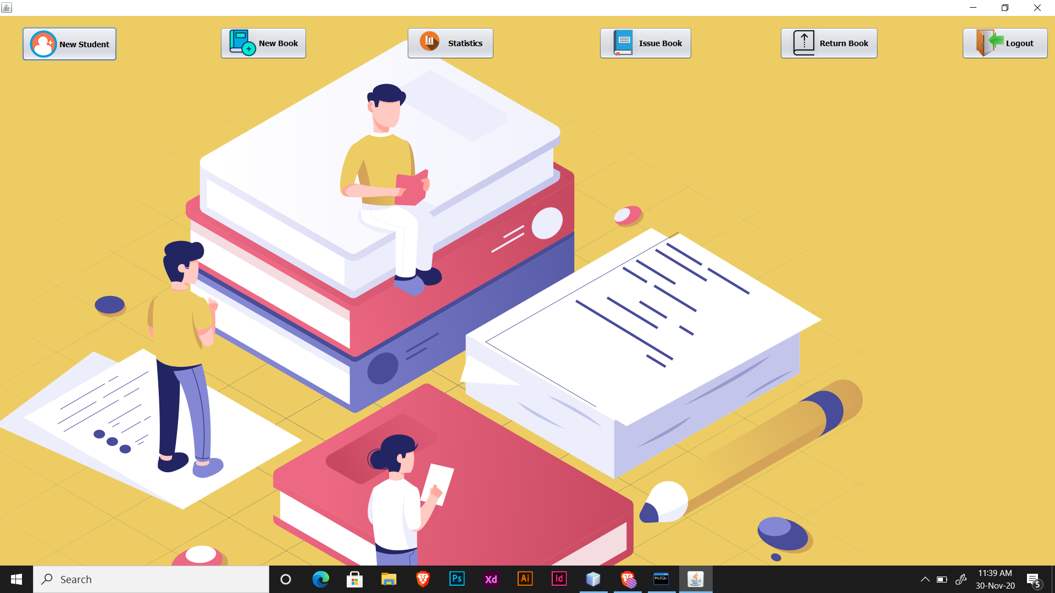
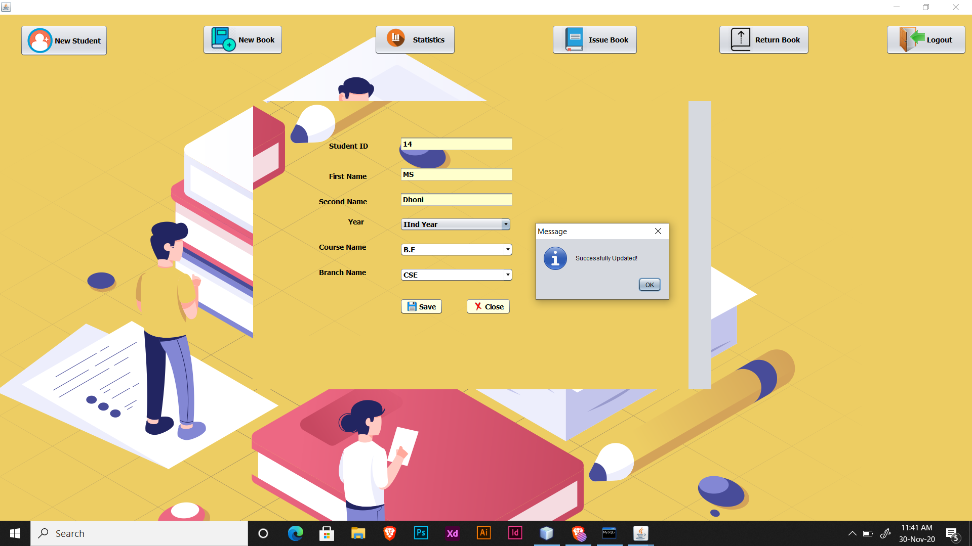
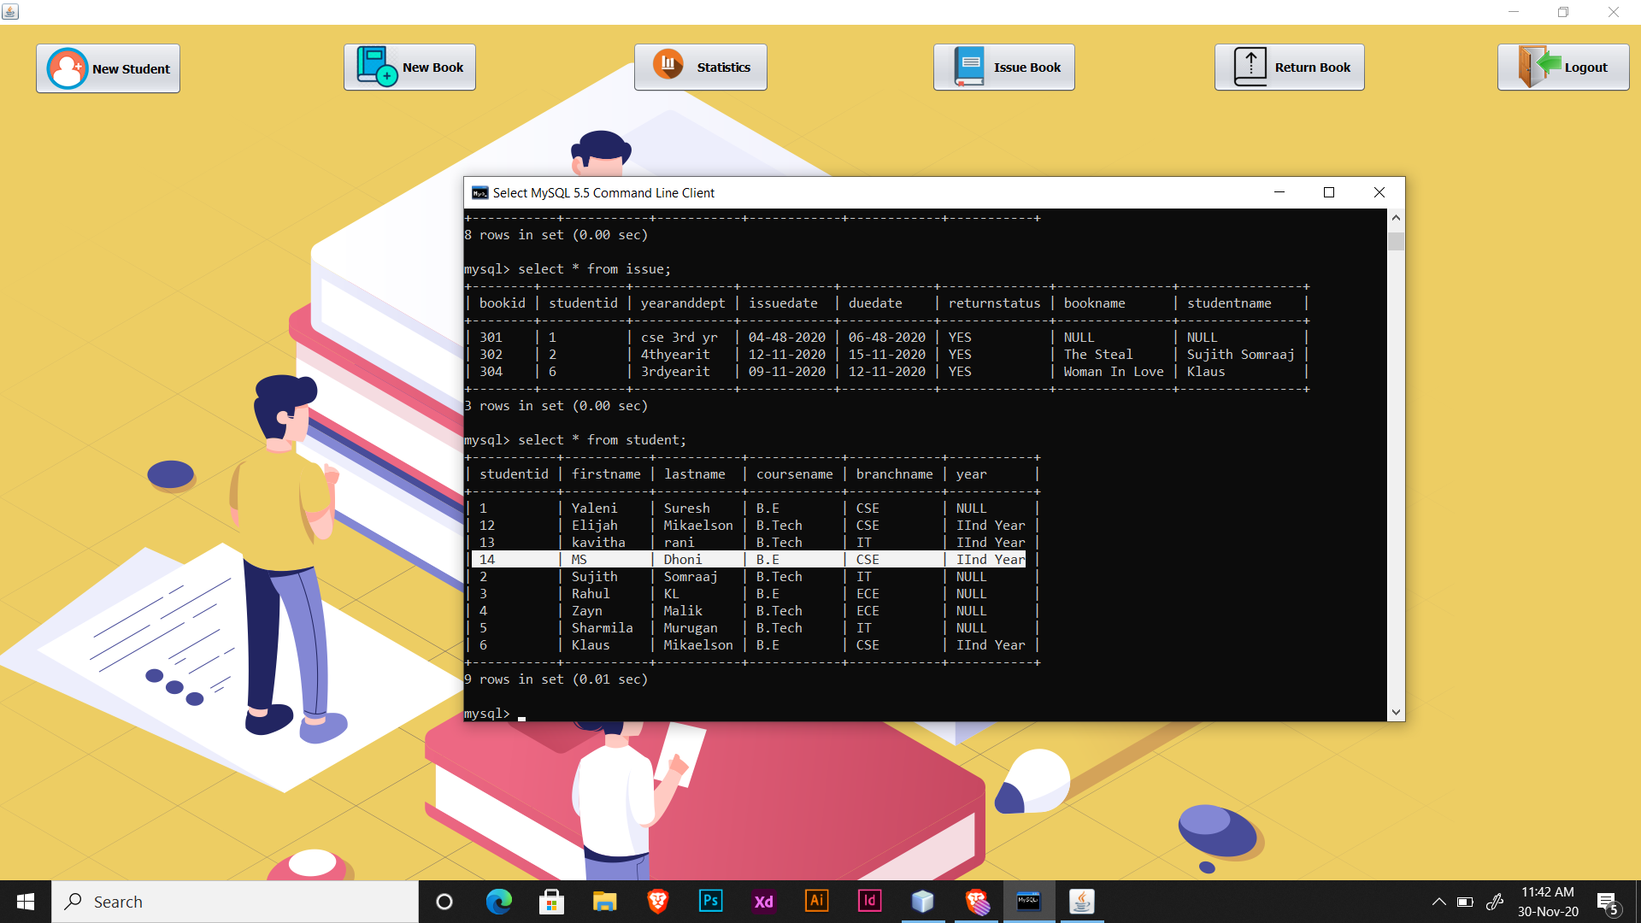

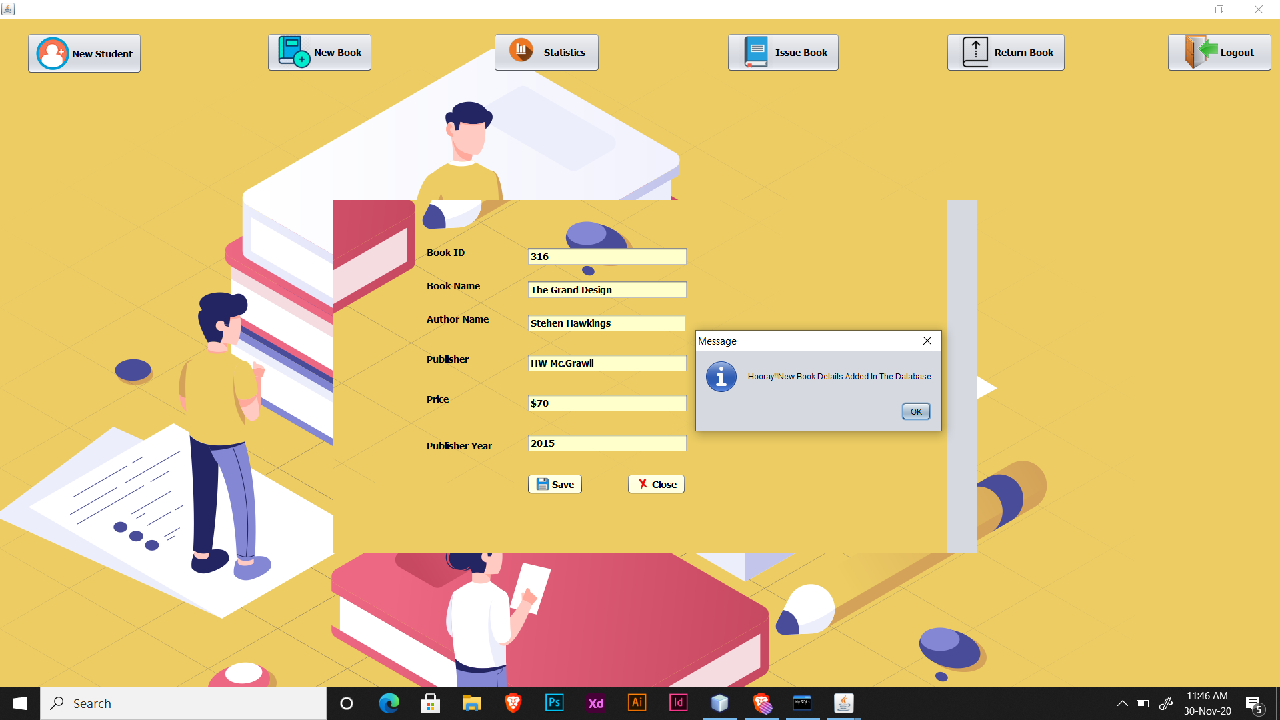
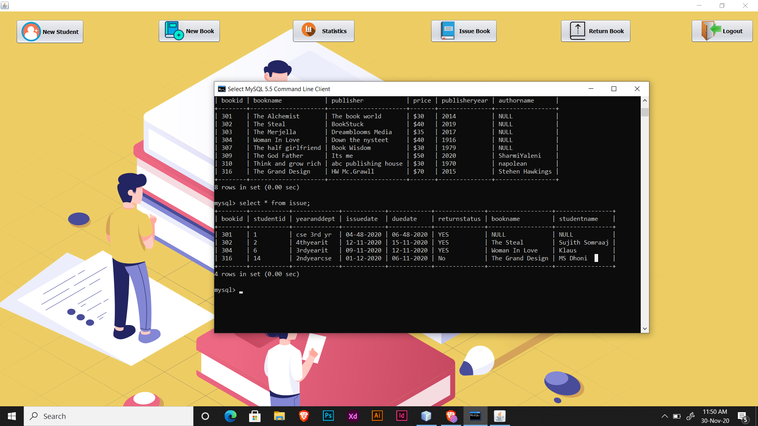
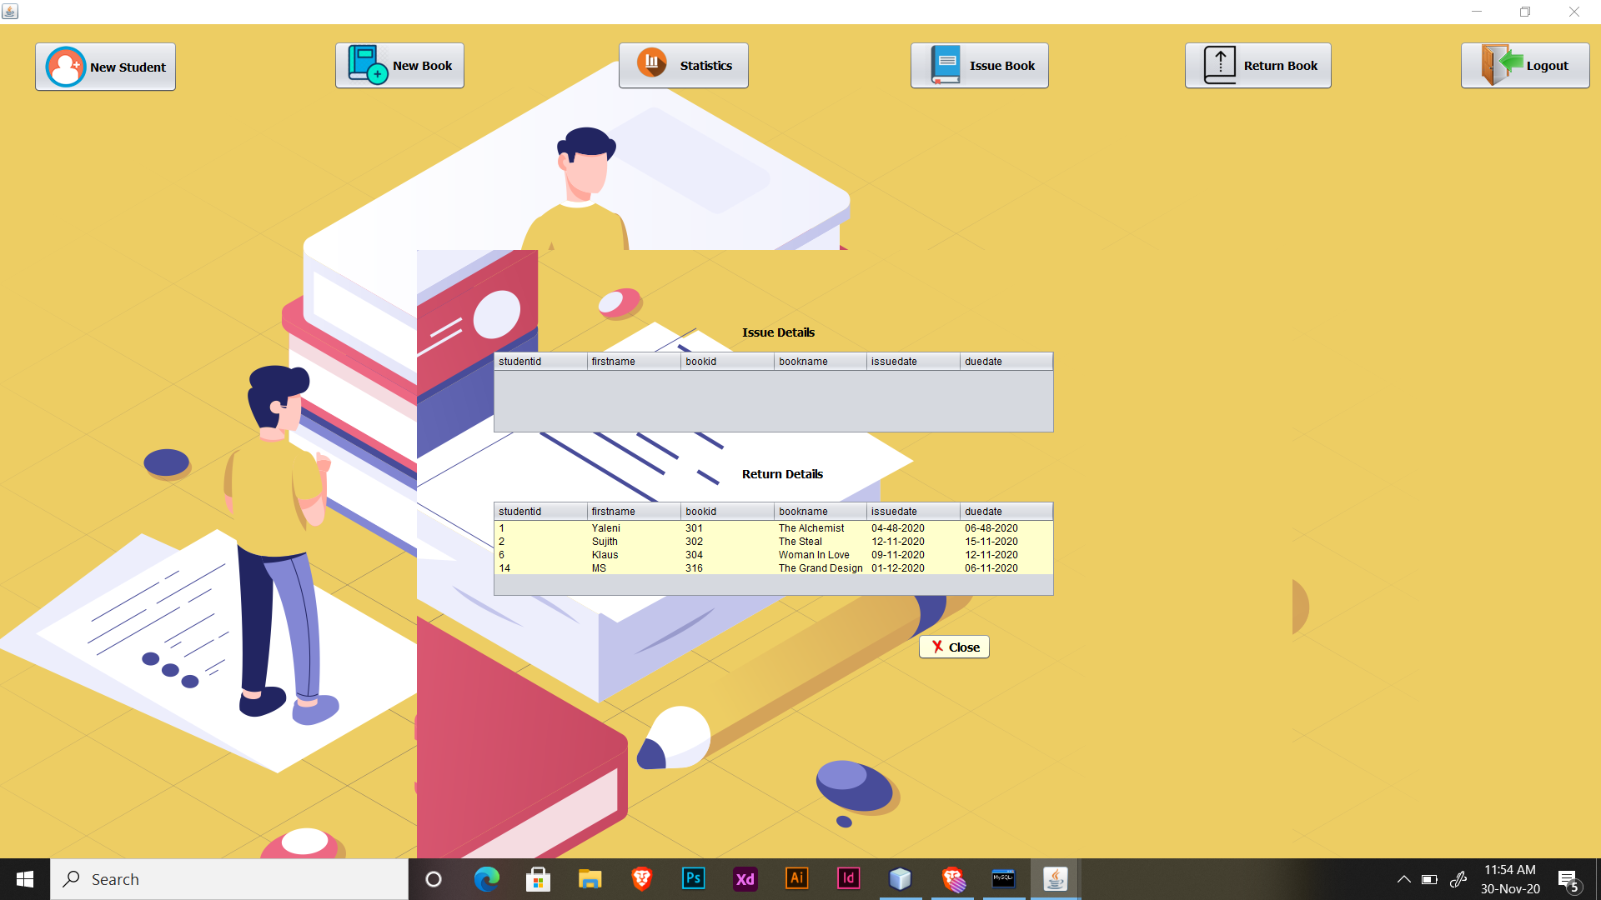

3.3 CONCLUSION:
The “LIBRARY MANAGEMENT SYSTEM” process made computerized to reduce human errors and to increase the efficiency. The main focus of this project is to lessen human efforts. The maintenance of the records is made efficient, as all the records are stored in the ACCESS database, through which data can be retrieved easily. The navigation control is provided in all the forms to navigate through the large amount of records. If the numbers of records are very large then user has to just type in the search string and user gets the results immediately. The editing is also made simpler. The user has to just type in the required field and press the update button to update the desired field. The Books and Students are given a particular unique id no. So that they can be accessed correctly and without errors. Our main aim of the project is to get the correct information about a particular student and books available in the library. The problems, which existed in the earlier system, have been removed to a large extent. And it is expected that this project will go a long way in satisfying users requirements. The computerization of the Library Management will not only improves the efficiency but will also reduce human stress thereby indirectly improving human recourses requirements.

